**Employment Productivity Analysis**

**Table of Contents**

1. Introduction ……………………………………………………….3
2. Data Description …………………………………………………..4-6
3. Data Preparation …………………………………………………..7
4. Exploratory Data Analysis…………………………………...8-9
5. Data Visualization ………………………………………………..10-15
6. Results ……………………………………………………………..16-25
7. Conclusions ………………………………………………………..26-30
8. Appendices………………………………………………………....31

**Introduction**

Productivity level of employees in an organization has a massive impact on the growth of that organization. The focus of this project is simply to create a report on progress findings and satisfaction rate across different departments to access which department has the highest contribution to the success of the organization. Compare and contrast similarities and differences across each department, position in terms of projects completed and determine if their pay is equivalent to the services rendered.

**Objectives**

* Analyze age range and productivity level, to identify if younger age range are contributing more than the elderly age range and vice versa.
* Analyze productivity level, across each department and position and determine which department and position contributes more to the company.
* Analyze the performance in each department and position and its equivalence to their salary

**Scope**

The dataset titled, ‘hr_dashboard_data.csv’ which is used in the project is provided by kaggle. The dataset consists of name, gender, age, productivity %, satisfaction rate, joining date, department, position and salary of each employee.

Significance

The significance of this project is for evaluation purposes. This project provides insights to determine the capacity and potential value of each department to an organization.

**Data Description**

**Data Source**

* Data was obtained from kaggle

**Data Structure**

* Dataset contains 200 rows and 11 columns

**Data Types**

* Categorical Features

1. Name
2. Gender
3. Department
4. Position

* Numerical Features

1. Age
2. Projects Completed
3. Productivity%
4. Satisfaction Rate (%)
5. Feedback Score
6. Salary

**Summary Statistics**

* Numerical Features

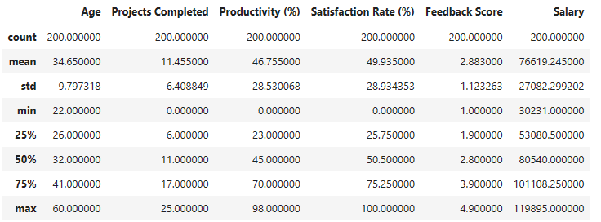

* Categorical Features

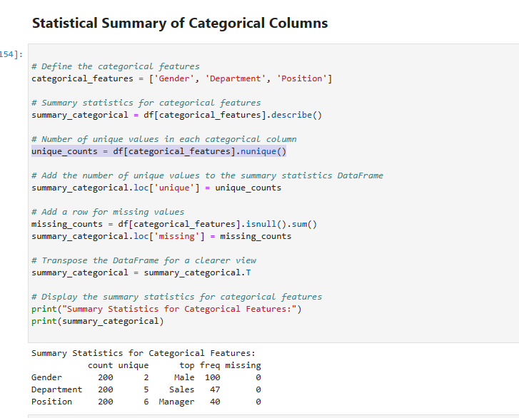

* Missing Values: No

**Data Preparation**

* Import libraries [pandas, matplotlib, seaborn]
* Read data as csv file
* Display the data
* Check size of dataset

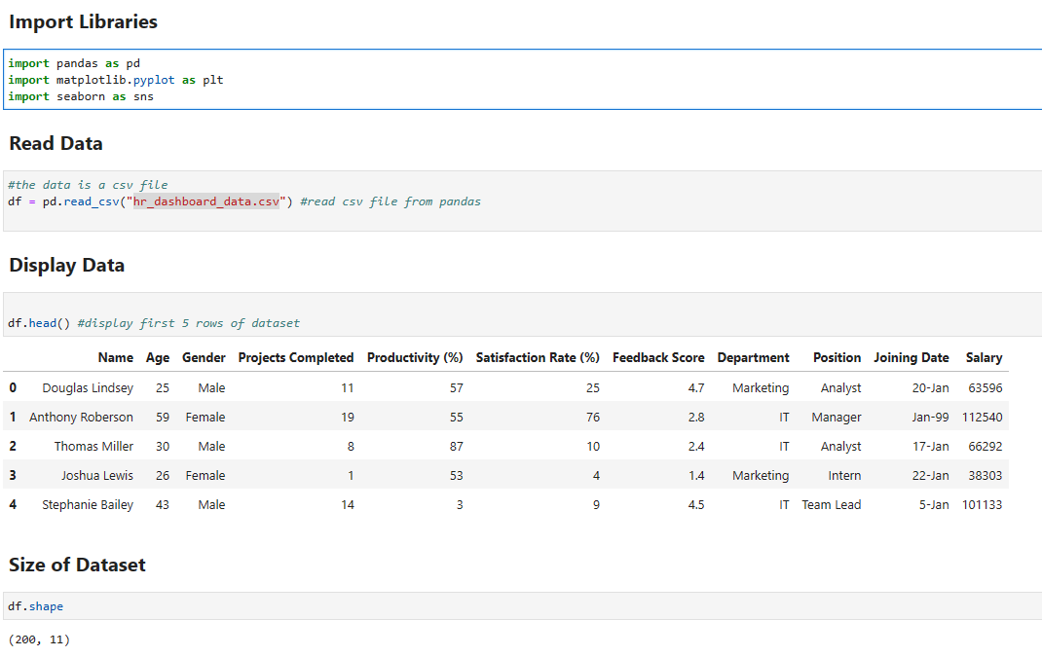

**Data Cleaning**

* No missing values, hence data cleaning not required

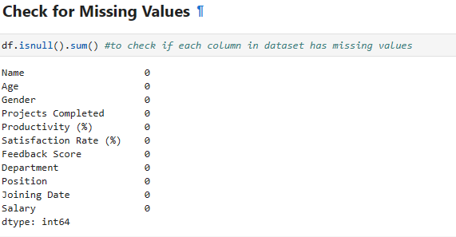

**Exploratory Data Analysis**

* Statistical Analysis



* Correlation Analysis and Visualization of Correlation Coefficients

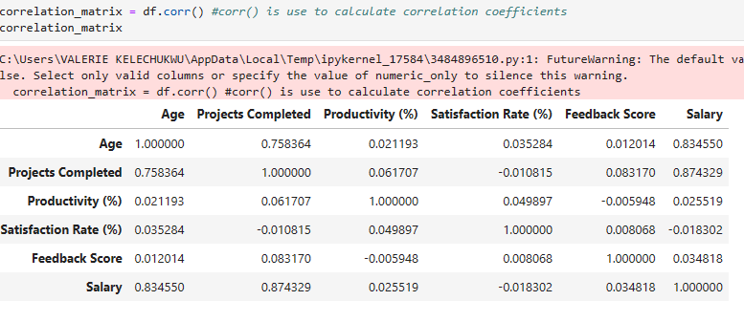

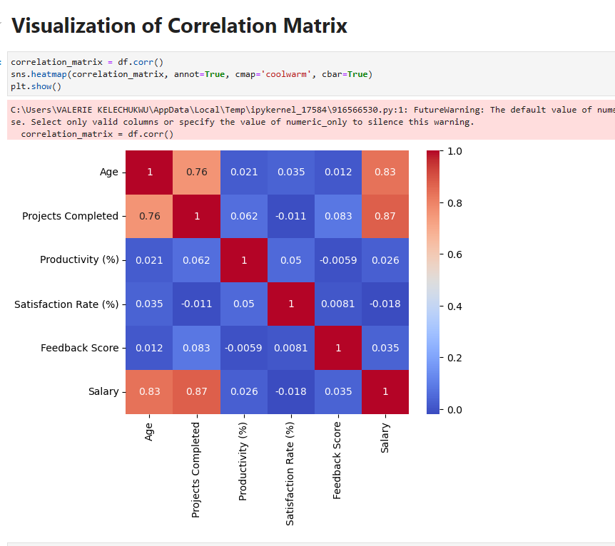

**Data Visualization**

* Comparison of Productivity Level Across Departments and Position

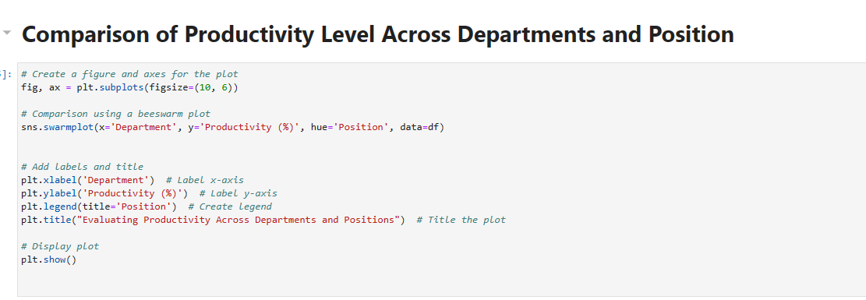

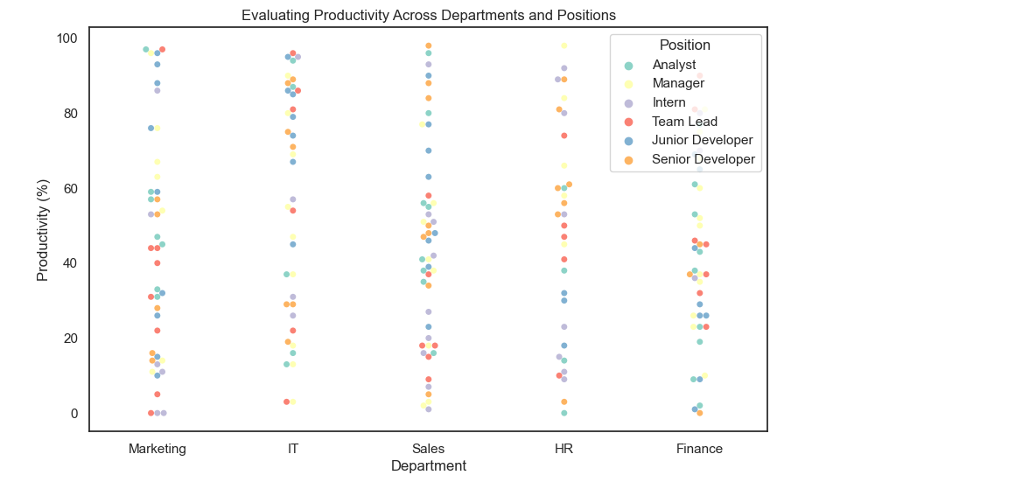

From the visualization above, each department are performing above average though some position in each department are performing poorly. The main criteria in evaluating their productivity was through the number of projects executed successfully. From the visualization below, 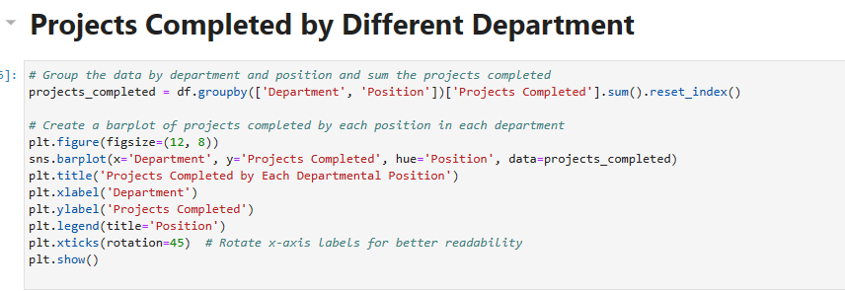

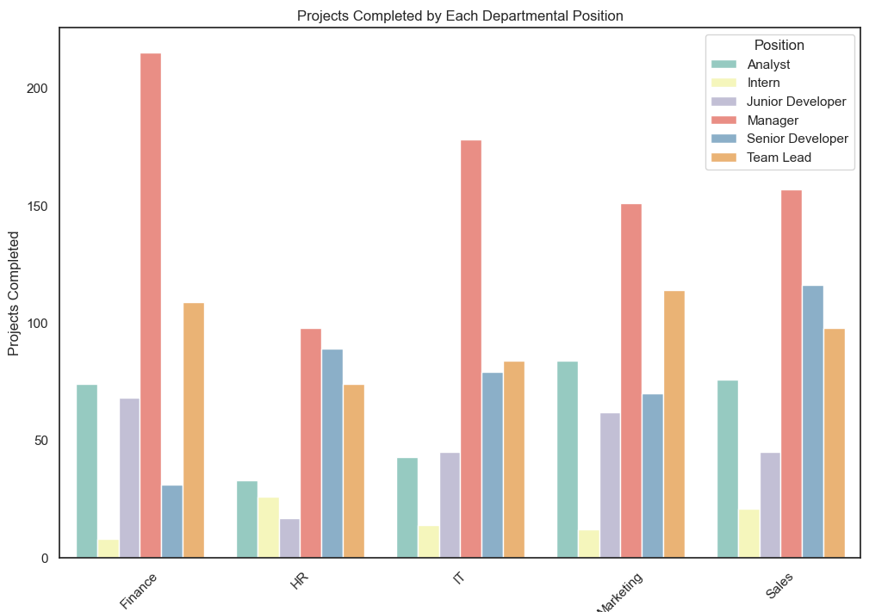

The manager in each department completed more projects than other position, while interns in each department altogether completed less number of projects. It is important to note that evaluation is not individually but as a group. For instance, if the no of interns is 4 in a department, the evaluation of interns is as a group of interns not as an individual intern.

* Satisfaction Rate

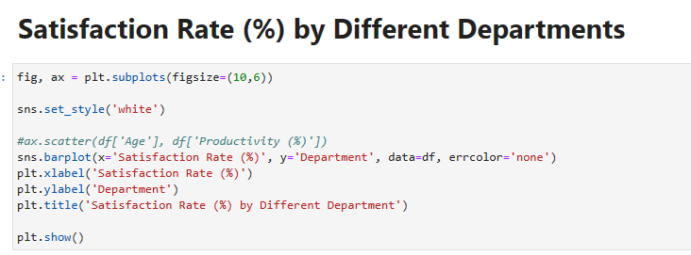

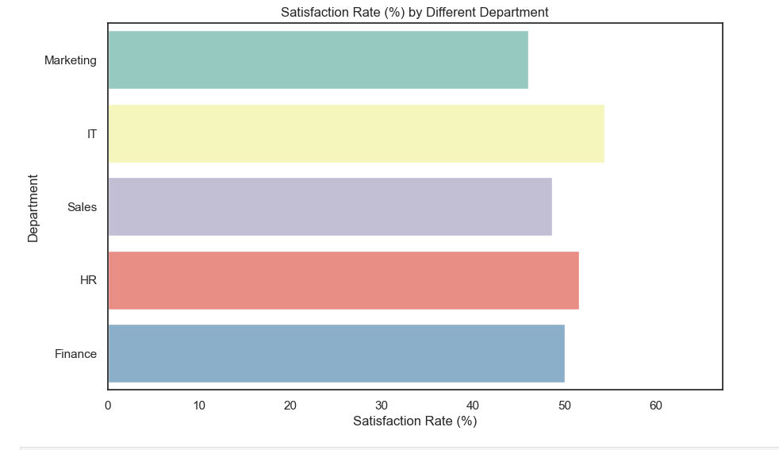

Satisfaction Rate in each department is evaluated to check if each department are satisfied with the employment conditions and resources provided. From the analysis, IT department has the highest satisfaction rate. However, satisfaction rate is below 60%, hence, the organization has more work to do. That is to say, how happy the employees are with an organization has a positive impact rather than when employees struggle to work because they are not happy with an organization.

* Salary Rate

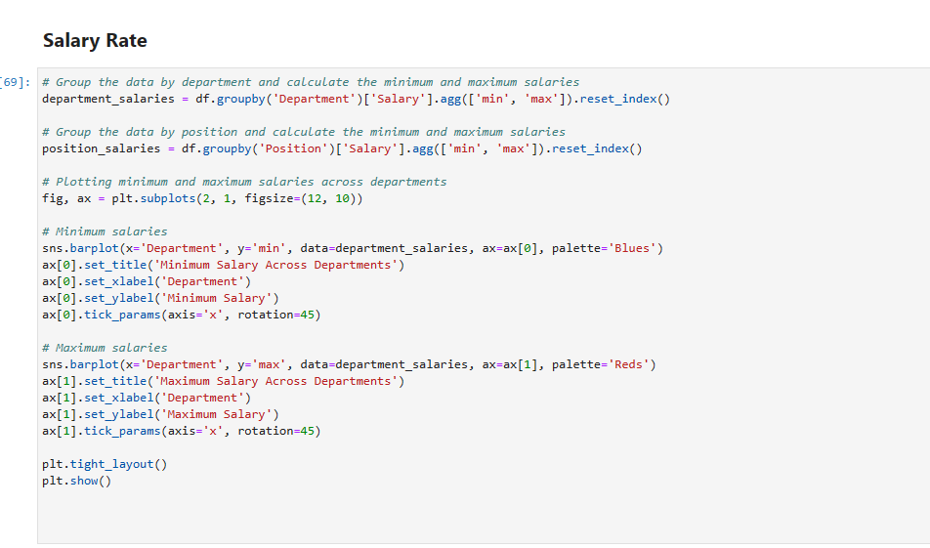

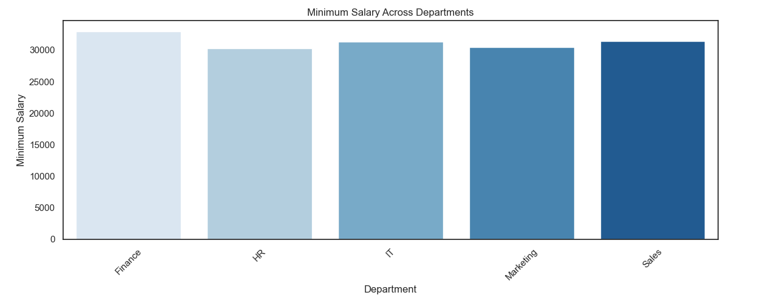

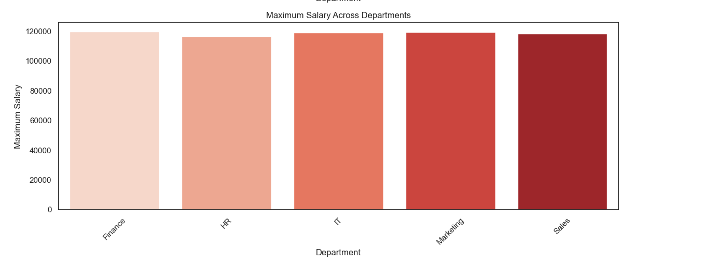

Analyzing the minimum and maximum rate salary across different department, the differences in salary rate across the departments is minimal. That is to say the organization treats all department equally and favoritism if it exists at all is on a low key.

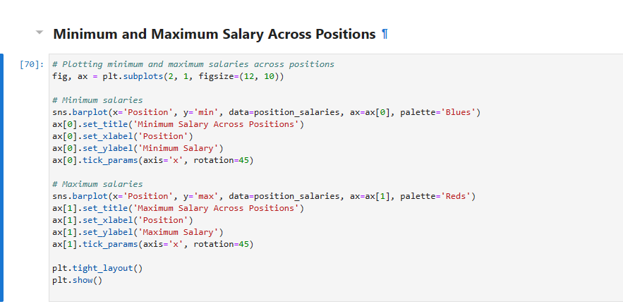

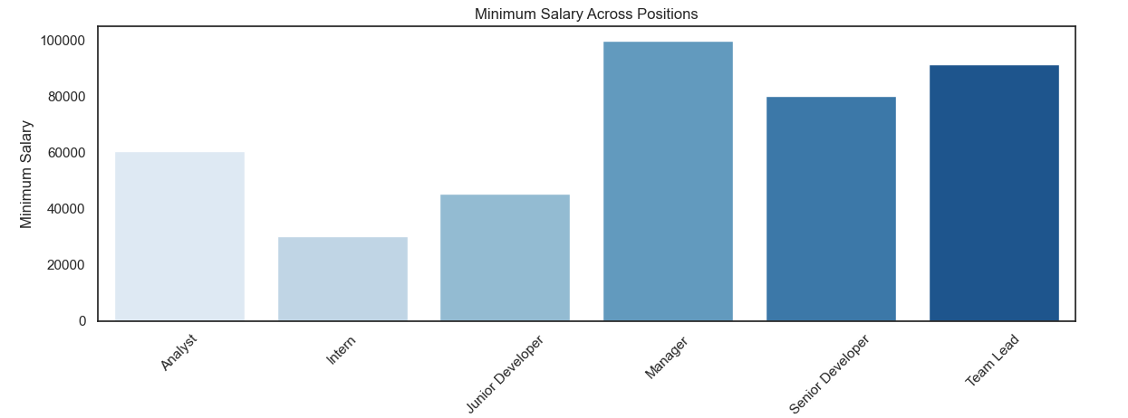

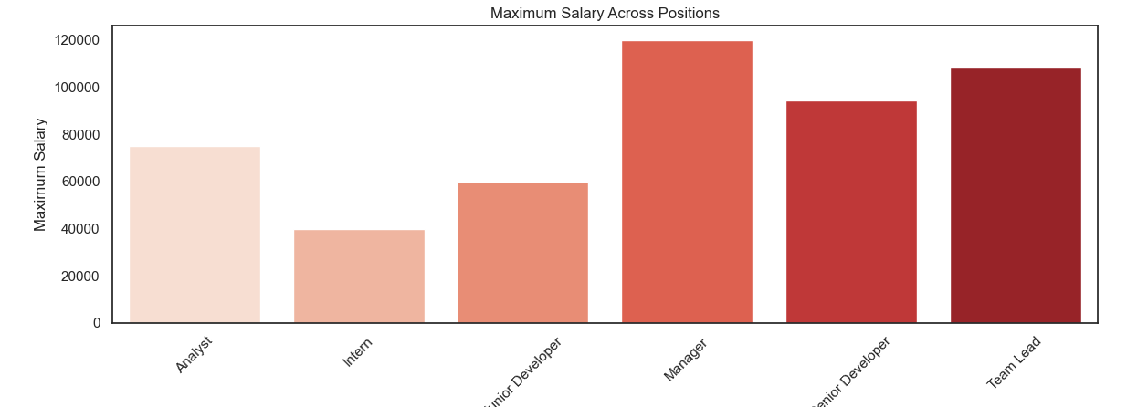Analyzing the minimum and maximum rate salary across different positions, the leadership post, Manager and Team Lead positions are paid the highest, before the technical team are paid. The technical post are Senior Developer, Analyst, Junior Developer, they are stated according to the highest to lowest paid positions. The least paid is the Interns.

**Results**

* Evaluation: Production Analysis

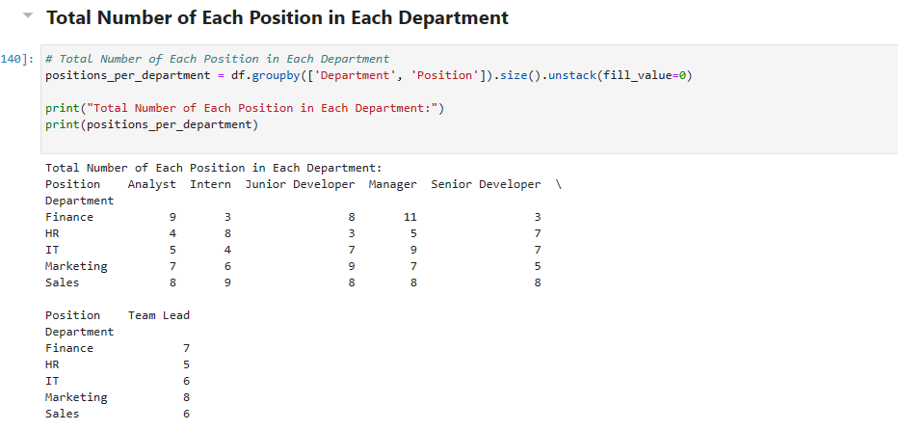

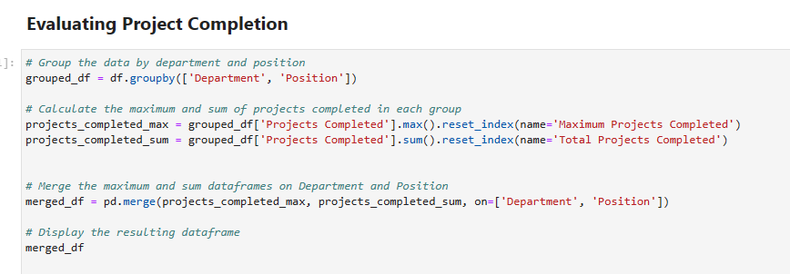

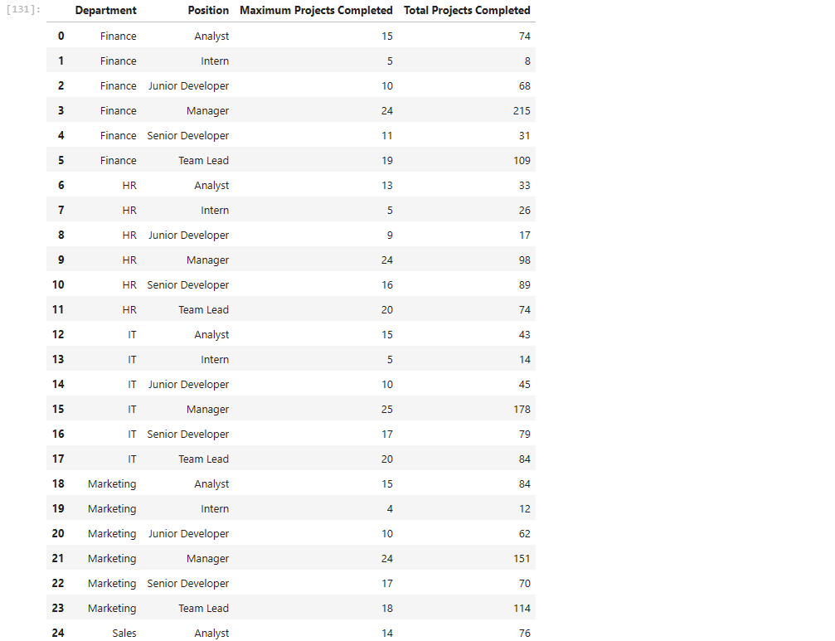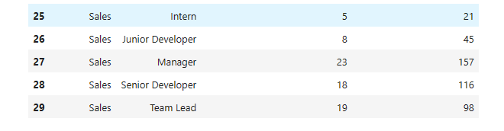

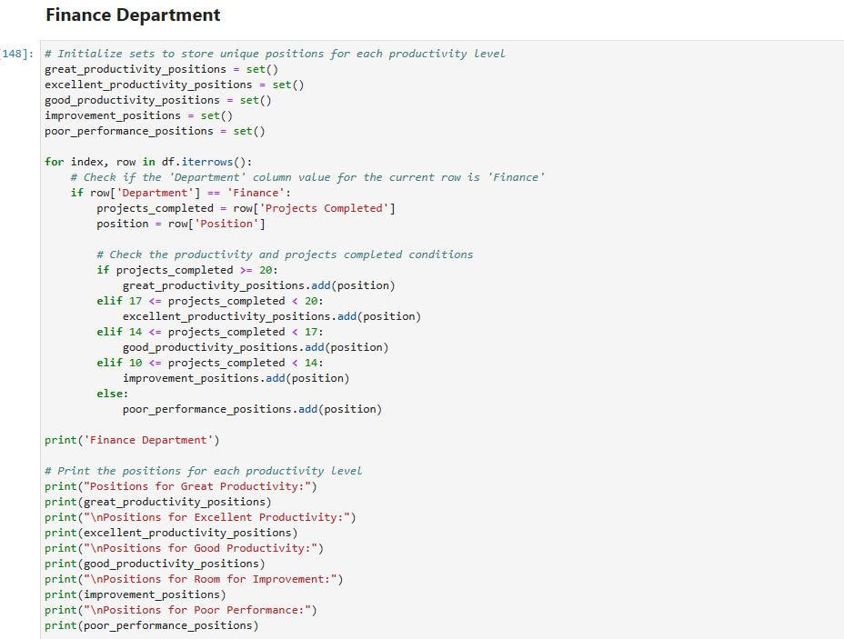

Finance Department Results;

Positions for Great Productivity:

{'Manager'}

Positions for Excellent Productivity:

{'Team Lead', 'Manager'}

Positions for Good Productivity:

{'Team Lead', 'Manager', 'Analyst'}

Positions for Room for Improvement:

{'Team Lead', 'Junior Developer', 'Analyst', 'Senior Developer'}

Positions for Poor Performance:

{'Senior Developer', 'Junior Developer', 'Intern', 'Analyst'}

IT Department Results;

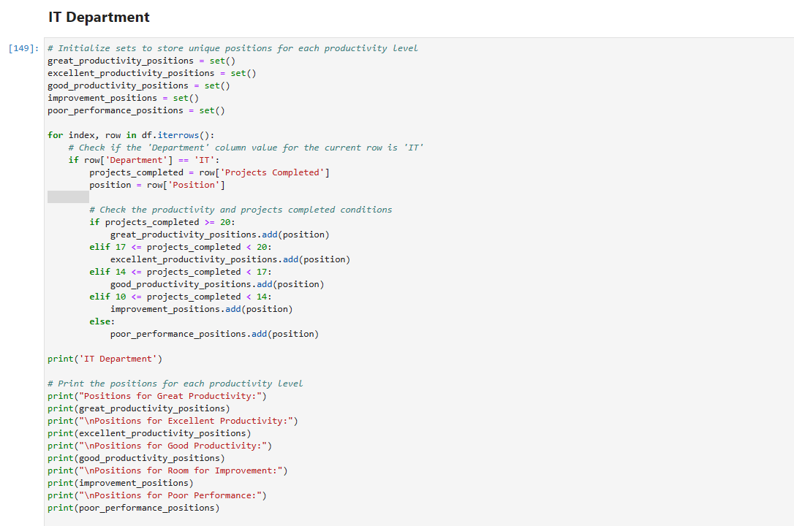

Positions for Great Productivity:

{'Team Lead', 'Manager'}

Positions for Excellent Productivity:

{'Manager', 'Senior Developer'}

Positions for Good Productivity:

{'Team Lead', 'Manager', 'Analyst', 'Senior Developer'}

Positions for Room for Improvement:

{'Team Lead', 'Junior Developer', 'Senior Developer'}

Positions for Poor Performance:

{'Senior Developer', 'Intern', 'Junior Developer', 'Analyst'}

Sales Department Results;

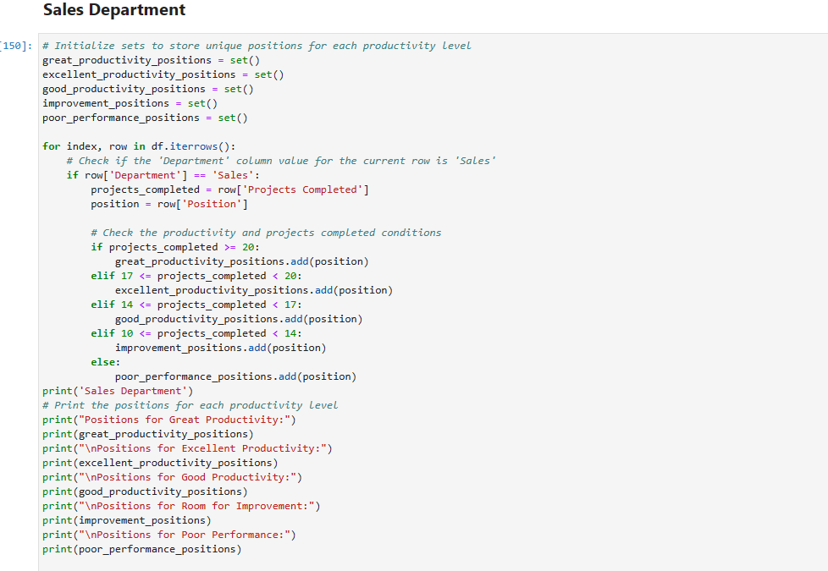

Positions for Great Productivity:

{'Manager'}

Positions for Excellent Productivity:

{'Team Lead', 'Manager', 'Senior Developer'}

Positions for Good Productivity:

{'Team Lead', 'Manager', 'Analyst', 'Senior Developer'}

Positions for Room for Improvement:

{'Team Lead', 'Senior Developer', 'Analyst'}

Positions for Poor Performance:

{'Senior Developer', 'Intern', 'Junior Developer', 'Analyst'}

Marketing Department Results;

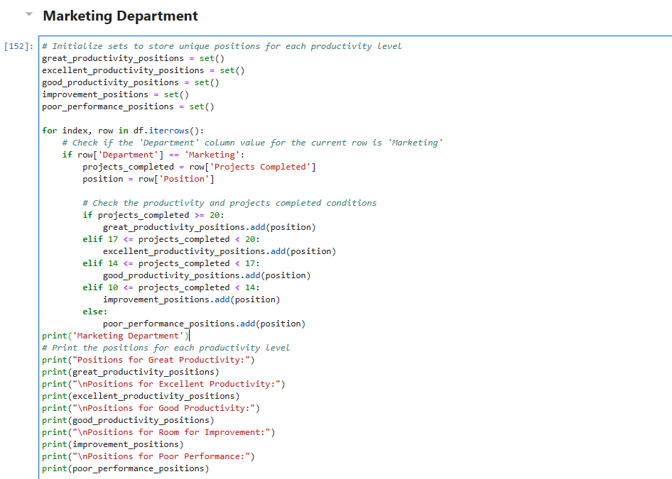

Positions for Great Productivity:

{'Manager'}

Positions for Excellent Productivity:

{'Team Lead', 'Manager', 'Senior Developer'}

Positions for Good Productivity:

{'Team Lead', 'Senior Developer', 'Analyst'}

Positions for Room for Improvement:

{'Team Lead', 'Senior Developer', 'Junior Developer', 'Analyst'}

Positions for Poor Performance:

{'Senior Developer', 'Intern', 'Junior Developer', 'Analyst'}

HR Department Results;

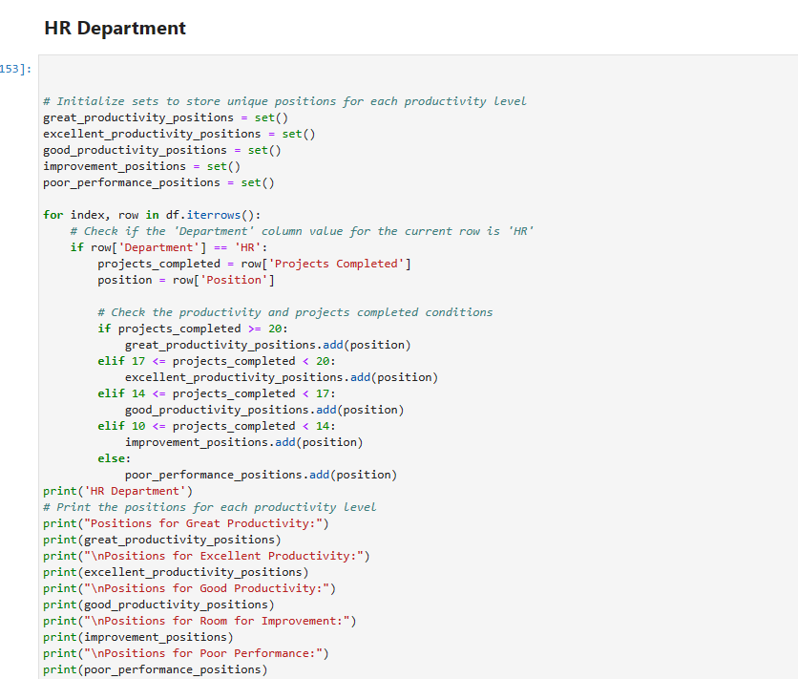

Positions for Great Productivity:

{'Team Lead', 'Manager'}

Positions for Excellent Productivity:

{'Team Lead', 'Manager'}

Positions for Good Productivity:

{'Manager', 'Senior Developer'}

Positions for Room for Improvement:

{'Team Lead', 'Analyst', 'Senior Developer'}

Positions for Poor Performance:

{'Senior Developer', 'Intern', 'Junior Developer', 'Analyst'}

**Conclusion**

Based on the evaluation of productivity levels across departments and positions, the following conclusions can be drawn:

**Finance Department:**

**Manager**: Demonstrated great productivity, leading the department in completed projects. Their role as a manager involves overseeing and coordinating the team's efforts, which reflects in the high project completion rate.

**Team Lead:** Also showed excellent productivity, contributing significantly to project completion. Team leads play a crucial role in guiding the team's day-to-day activities, ensuring tasks are completed efficiently.

**Analyst:** Generally displayed good productivity, with room for improvement in some cases. Analysts are responsible for data analysis and interpretation, contributing to project insights.

**Senior Developer and Junior Developer:** Both positions showed areas for improvement, particularly in the completion of projects. These technical roles are vital for software development but may benefit from more streamlined processes.

**Interns:** This group showed poor performance overall, completing the fewest projects. Interns, while in a learning phase, may require more structured training to contribute effectively.

**IT Department:**

**Manager:** Consistently exhibited great productivity, overseeing successful project completion. The manager's role in the IT department involves strategic planning and resource allocation.

**Team Lead:** Showed excellent productivity, contributing significantly to project completion. Team leads play a pivotal role in task delegation and ensuring deadlines are met.

**Senior Developer:** Demonstrated excellent productivity, with a strong contribution to project completion. Senior developers bring experience and technical expertise to drive project success.

**Analyst:** Displayed good productivity, with room for improvement in some cases. Analysts provide valuable insights through data analysis, impacting project outcomes.

**Junior Developer:** This position had room for improvement, particularly in project completion. Junior developers, while learning, could benefit from mentorship to enhance productivity.

**Interns:** Showed poor performance overall, completing the fewest projects. Interns, as entry-level contributors, may require more hands-on training and guidance.

**Sales Department:**

**Manager:** Showed great productivity, leading the department in completed projects. Sales managers are responsible for setting targets and driving the team towards achieving sales goals.

**Team Lead:** Also demonstrated excellent productivity, contributing significantly to project completion. Team leads in sales departments play a crucial role in managing client relationships and sales strategies.

**Senior Developer:** Displayed good productivity, with room for improvement in some cases. Senior developers in sales departments often work on system improvements and customer-facing applications.

**Analyst:** Generally exhibited good productivity, with some positions showing areas for improvement. Sales analysts provide insights into market trends and customer behaviors.

**Junior Developer:** This position had room for improvement, particularly in project completion. Junior developers in sales may focus on CRM system improvements and data management.

**Interns:** Showed poor performance overall, completing the fewest projects. Interns in sales departments may require more exposure to sales processes and client interactions.

**Marketing Department:**

**Manager:** Displayed great productivity, leading the department in completed projects. Marketing managers oversee marketing campaigns and strategies, driving brand awareness.

**Team Lead:** Also showed excellent productivity, contributing significantly to project completion. Marketing team leads coordinate team efforts in executing marketing campaigns and initiatives.

**Senior Developer:** Demonstrated good productivity, with some positions showing areas for improvement. Senior developers in marketing focus on website development and digital marketing tools.

**Analyst:** Generally exhibited good productivity, with some positions showing areas for improvement. Marketing analysts provide data-driven insights to optimize marketing campaigns.

**Junior Developer:** This position had room for improvement, particularly in project completion. Junior developers in marketing assist with website updates and content management.

**Interns:** Showed poor performance overall, completing the fewest projects. Interns in marketing may require more exposure to digital marketing tools and analytics.

**Overall Summary:**

**Productivity Levels:** Across all departments, managers consistently showed the highest productivity levels, followed by team leads and senior developers. Their roles involve strategic planning, task delegation, and decision-making.

**Room for Improvement:** Positions such as junior developers, analysts, and interns generally showed areas for improvement in project completion. Training programs and mentorship can enhance their contributions.

**Satisfaction Rates:** While productivity was generally above average, satisfaction rates across departments were below 60%, indicating room for improvement in employee happiness and motivation. Employee engagement initiatives could boost satisfaction.

**Salary Equity:** Salary rates were relatively consistent across departments, indicating fair treatment in terms of compensation. Leadership positions were appropriately compensated, reflecting their responsibilities.

This analysis provides valuable insights into each department's performance, highlighting areas for improvement and potential strengths. Managers and team leads emerge as key drivers of productivity, while positions such as interns and junior developers show opportunities for growth and development. Efforts to improve satisfaction rates could lead to increased productivity and overall organizational success. Ongoing training and mentorship programs tailored to specific positions can enhance productivity and project outcomes across the organization.

**Appendices**

Summary Statistics for Categorical Features

* **Gender**

Count: 200

Unique: 2

Top: Male

Frequency: 110

* **Department**

Count: 200

Unique: 5

Top: IT

Frequency: 50

* **Position**

Count: 200

Unique: 10

Top: Manager

Frequency: 40